The application interface is shown below. In the free version, only the top-most check-box in either check-box list is operative.

Use either of these buttons to select Excel files for these operations. These operations can be performed on multiple files and do not require user intervention.

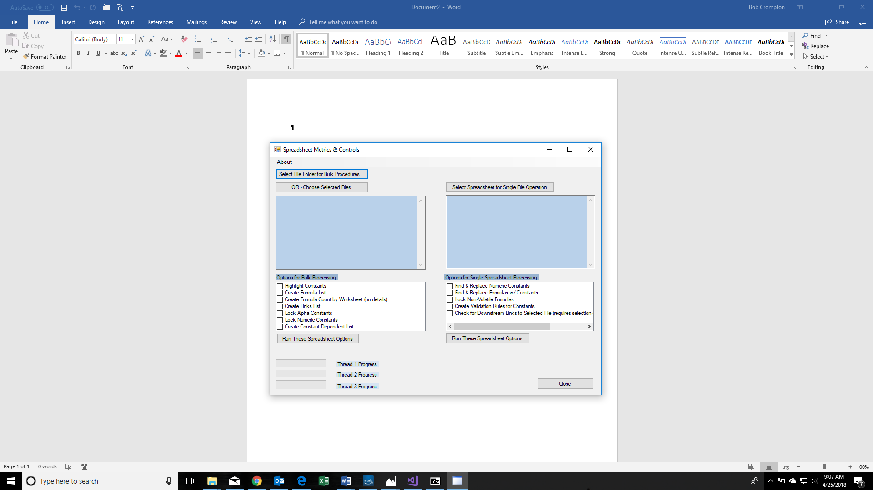

Use this button to select an Excel file for these operations. These operations require user intervention, so only a single file is processed at a time. At the users option, changes are saved.

Use this button, or this button to start processing.

These indicators show progress. If multiple files are chosen, up to 3 threads are used.

This is what the display looks like when you have chosen a single file for the options in the check-box on the left side of the screen.

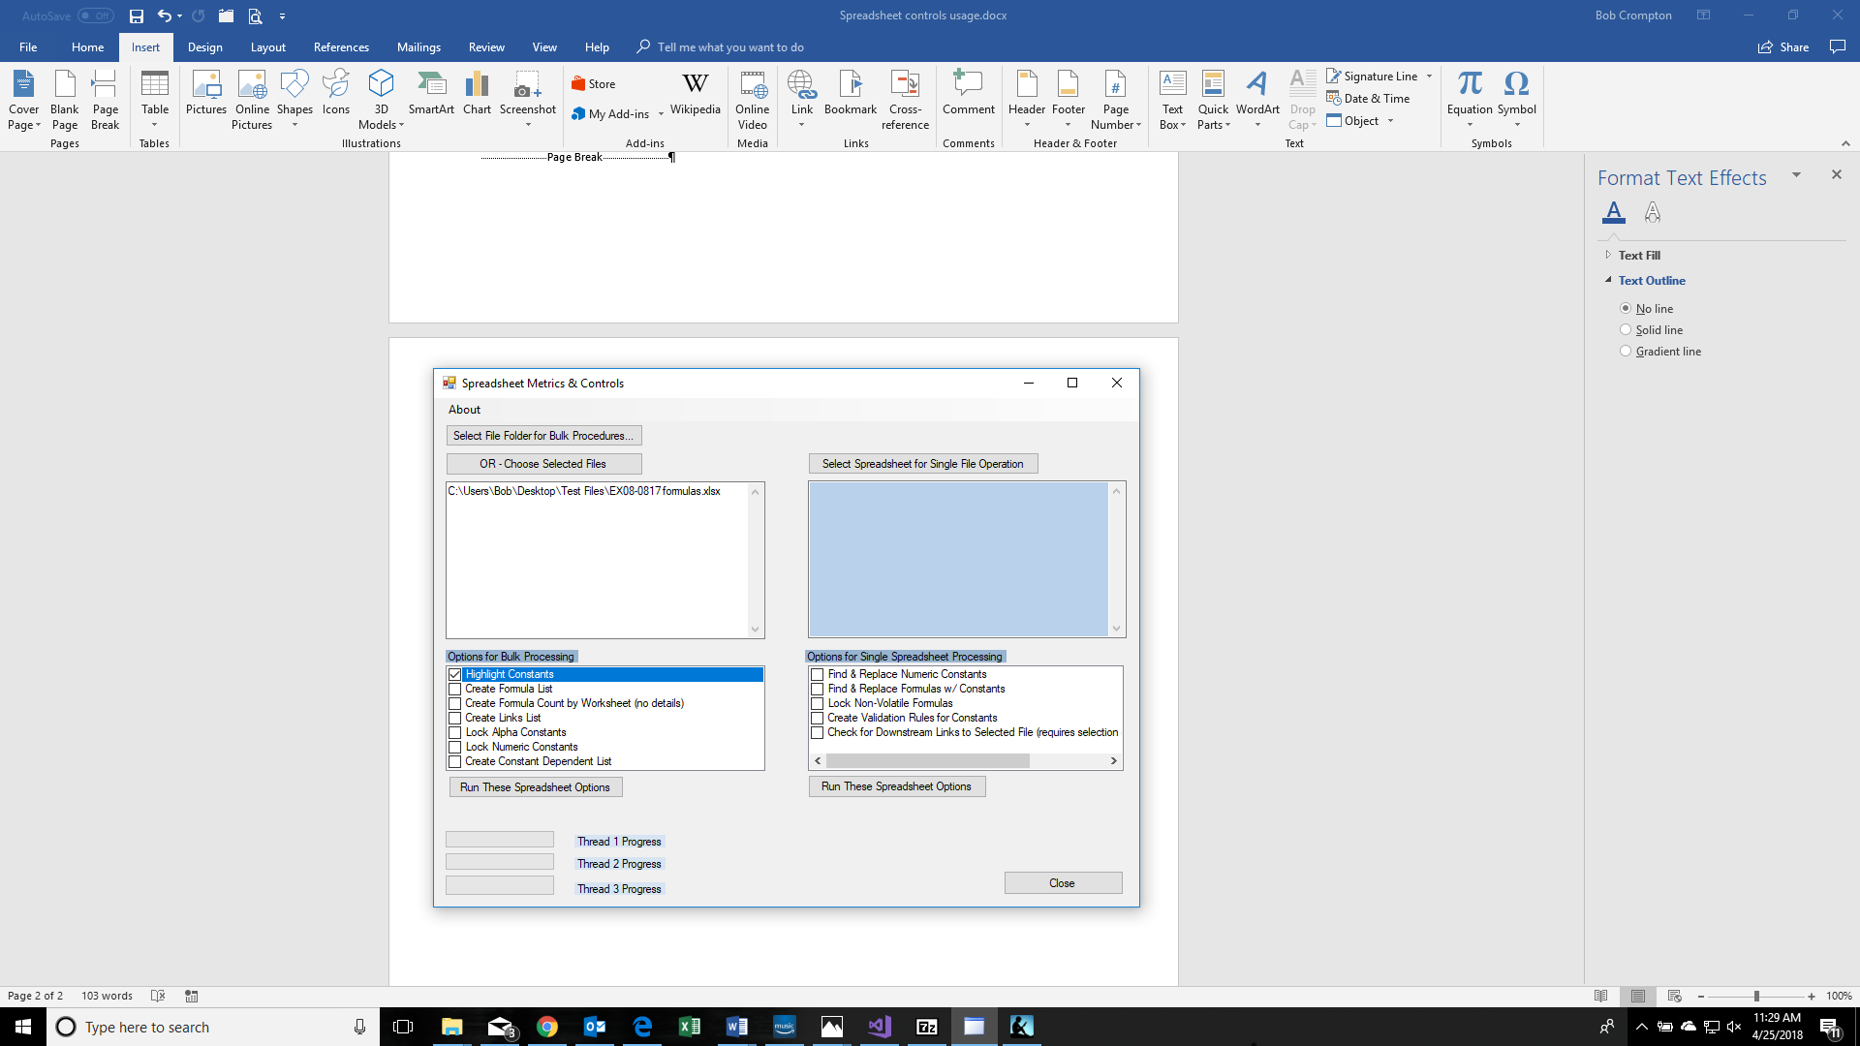

Below is the corresponding display looks like when you have chosen a single file for the options in the check-box on the right side of the screen.

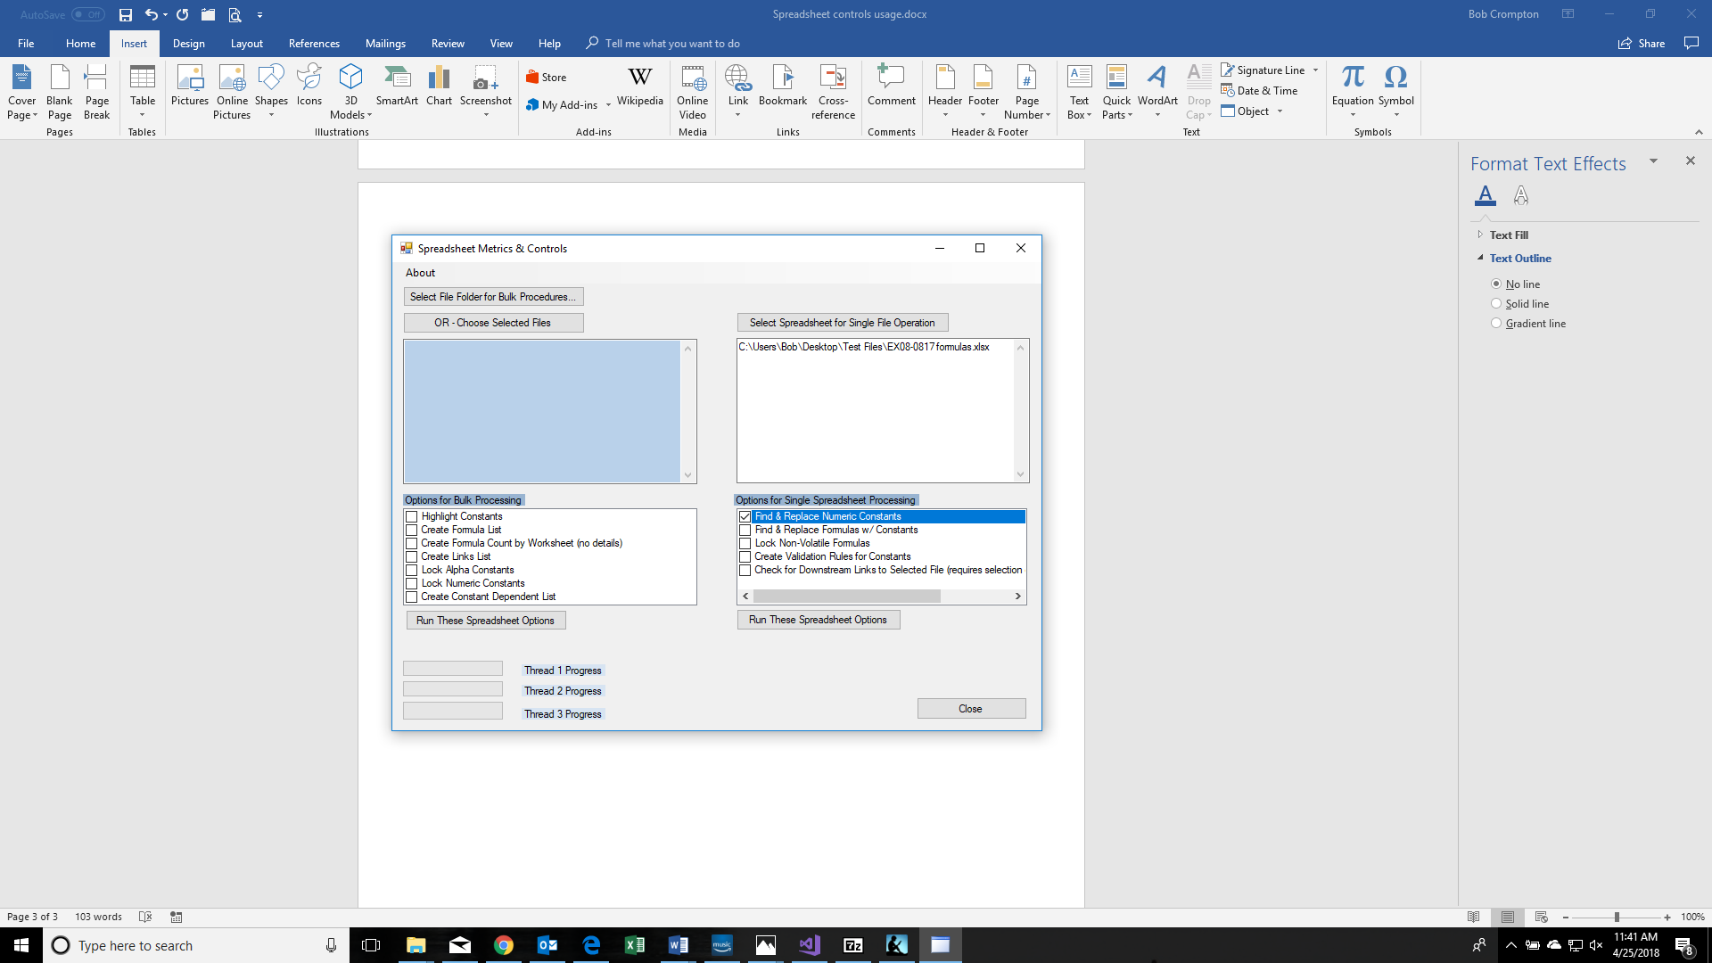

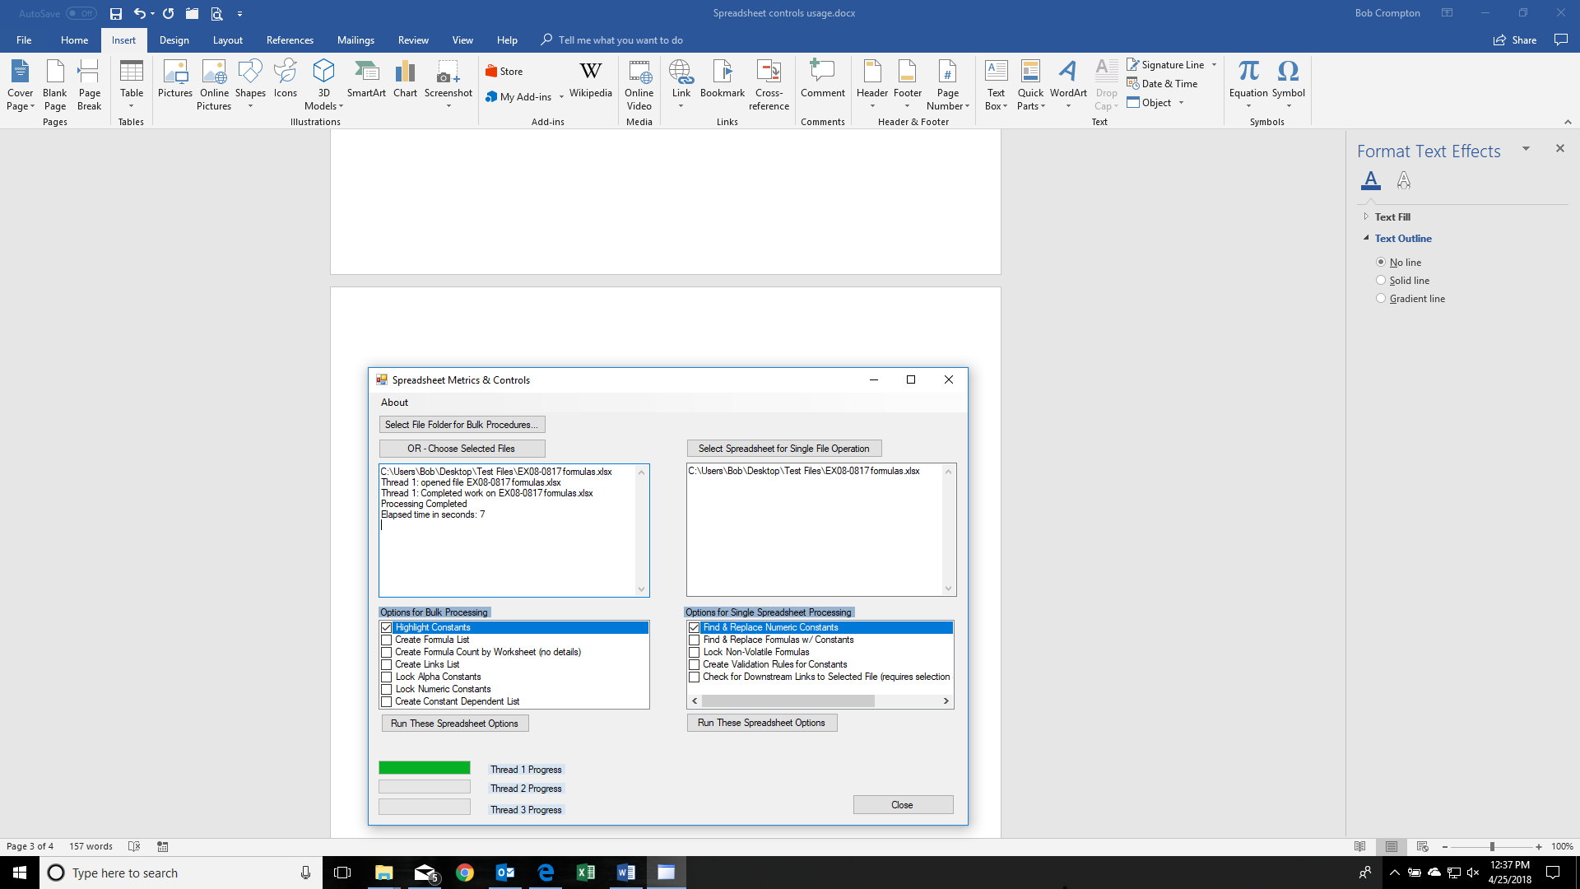

During processing, various messages are created in the text box. In addition, the Progress Bar(s) show completion for each of the tasks

When using the “Find & Replace Numeric Constants” option from the right-hand option box, the app will cycle through all of the workbooks in the spreadsheet. For each workbook, you will get two user input boxes. The first asks for a materiality limit. Any constant with a magnitude/absolute value less than the input number will be ignored. If you want to review all constants, set the input to zero.

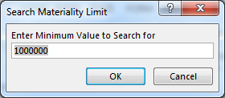

The second input box is for the search range. You can manually enter the search range, but it is easier to use mouse operations for this.

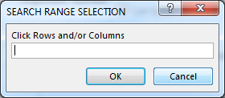

After cycling through each of the worksheets in the spreadsheet, the app will give you the option to save the changes (if any) or to discard them

